How to Order [Refer - https://metastatinsight.com/how-to-order]
Ordering a market research report from Globe Market Research is simple, secure, and designed to help buyers receive the right research support without delay. Whether you need a syndicated industry report, a customized market study, or analyst support for a specific business question, our ordering process ensures clarity at every step.
Our team assists clients before and after purchase so they can select the most relevant report, understand the scope of coverage, and receive timely access to the required market insights.

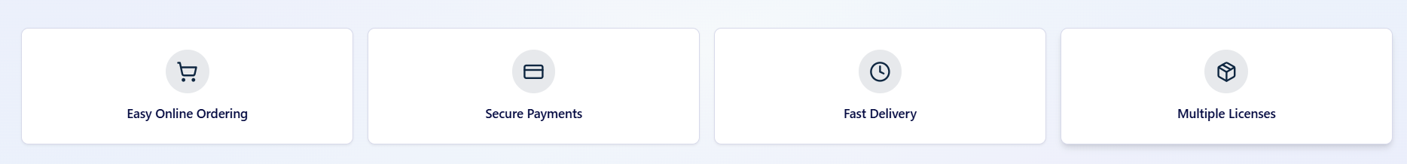
Two Easy Ways to Order

Method 1: Order Online
Online ordering is the fastest way to purchase a report. Visit the report page, review the scope and table of contents, select the preferred license type, and proceed with the purchase option available on the page. After submitting the order, you will be directed to the payment process. Once payment is confirmed, the report access or delivery details will be shared with the registered email address.

Step-by-Step Online Ordering Process
- Visit the required market research report page.
- Review the report description, segmentation, regional coverage, and table of contents.
- Select the suitable license type.
- Click on the purchase or buy option.
- Complete the secure payment process.
- Receive order confirmation and report delivery details by email.

Method 2: Order Through Email
Clients can also place an order by contacting the Globe Market Research team directly through email. This option is useful for custom research requests, corporate purchases, procurement approvals, invoice-based payments, or bulk report requirements. When sending an order request, please include your name, company name, report title, license type, billing details, and any specific customization or delivery requirement.

Step-by-Step Email Ordering Process
- Identify the report or research topic you want to purchase.
- Send your order request to the sales or support team.
- Mention the report title, license type, company details, and contact information.
- Add any customization needs, target region, or urgent delivery requirement.
- Our team will review the request and share the next steps.
- After payment confirmation, the report will be delivered as per the agreed timeline.

Available License Types
Choosing the right license is important because it defines how the report can be used within your organization. Globe Market Research offers different license options based on user access and business needs.

Single User License
A single user license is suitable for one individual buyer. The report access is limited to one authorized user and cannot be shared across teams, departments, or external parties.

Multi User License
A multi user license is suitable for a small team within the same organization. It allows selected users to access the report for internal business use, depending on the agreed license terms.

Corporate License
A corporate license is suitable for wider organizational access. It is commonly used by companies that need report access across multiple teams, departments, business units, or group-level decision makers.

Request a Sample Before Ordering
Clients may request a sample copy before placing an order. A sample helps buyers understand the report format, research depth, coverage style, and data presentation before making a purchase decision. You can also request the table of contents, segment coverage, regional scope, or analyst clarification before confirming your order.

Customization Support
If the published report does not fully match your business requirement, Globe Market Research can provide customization support. This may include additional country analysis, company profiling, segment-level insights, competitive benchmarking, pricing analysis, demand assessment, or forecast support. Customization requests are reviewed by our analyst team before confirmation. The final scope, timeline, and cost are shared based on the research requirement.

Payment and Invoice Support
Payments can be completed through the approved payment methods shared during the ordering process. For corporate clients, invoice-based payment support may be provided based on procurement needs and order confirmation. After successful payment, the invoice and order confirmation details will be shared with the buyer.

Report Delivery
Once payment is verified, the report is delivered through email or secure digital access. Standard report delivery is completed as per the timeline confirmed during the order process. For custom research projects, delivery time may vary depending on the depth of research, analyst work required, and scope of customization.

Need Help Ordering?
Our team is available to assist with report selection, license options, sample requests, payment support, customization, and delivery-related questions.
You can contact us for:
- Report purchase support
- Sample copy request
- Table of contents review
- License selection guidance
- Custom research inquiry
- Bulk report purchase
- Invoice and payment assistance
- Analyst discussion request

Why Order from Globe Market Research?
Globe Market Research provides structured and decision-focused market intelligence for business planning, competitive analysis, investment evaluation, product strategy, and market entry decisions. Our ordering process is built to offer transparency, secure transactions, professional support, and timely access to relevant market insights.

Contact Our Team
For orders, sample requests, customization support, or payment assistance, please contact Globe Market Research through the email, phone number, or contact form available on the website.
Our team will review your request and guide you through the next step.

